Assignment No.4 – DHCP Starvation using Scapy.

DHCP Starvation Attack:

Illustration:

1. Clear dhcpd.leases and dhcpd.leases~ to release any leases that were previously allotted.
2. Increase the Router’s lease time to 24 hrs.
3. Now send a DHCP Discover message with Random MAC address to the router to starve addresses from the range of 10.10.111.100 – 10.10.111.200
4. Wait for an ACK message from the Router, if received add the IP address to the pool of starved addresses.
5. If ACK is not received, then send a request again requesting for the same IP address.
6. After all the ACKs are received the targeted router is out of IP addresses for lease. Thus DHCP Starvation is successful.

Leases before attack.

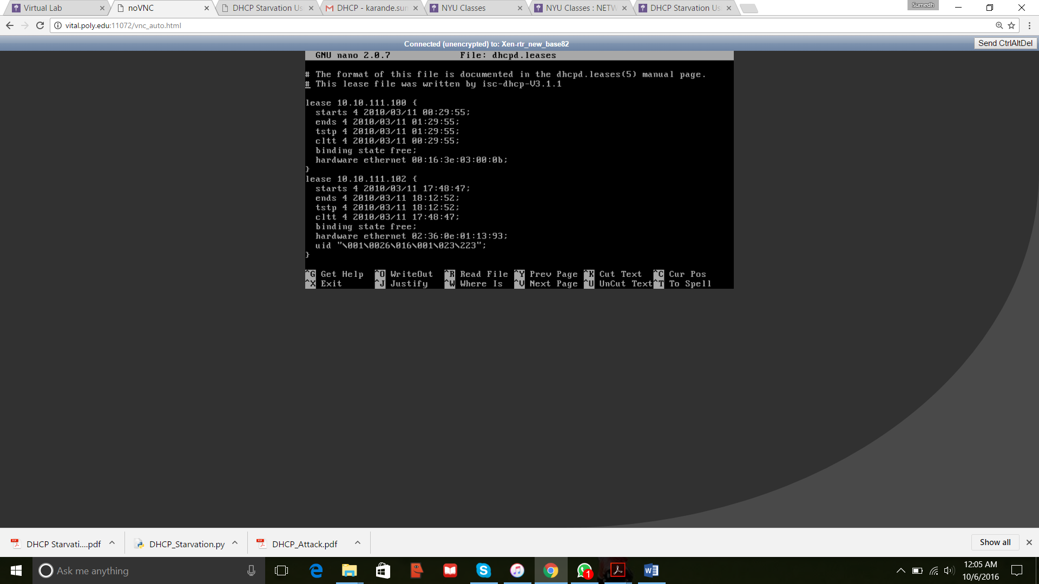

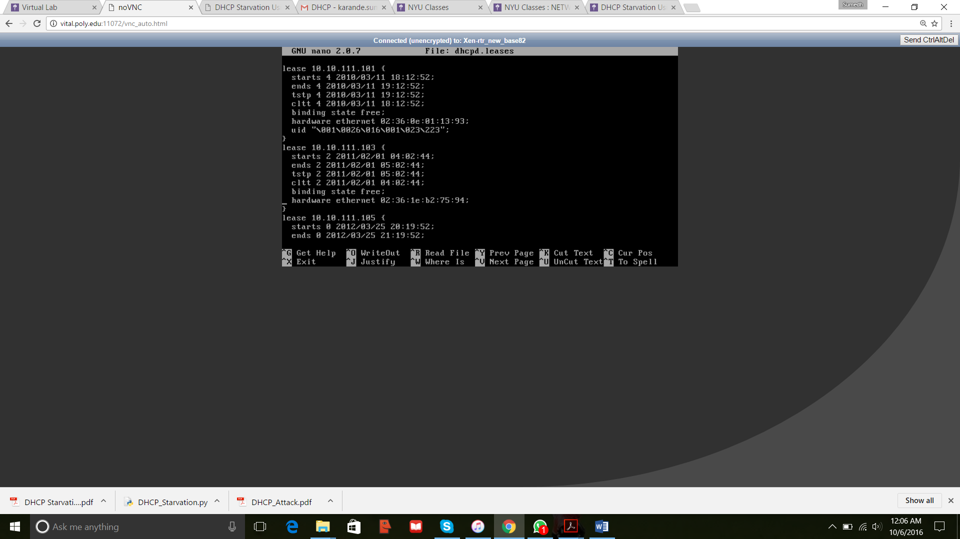

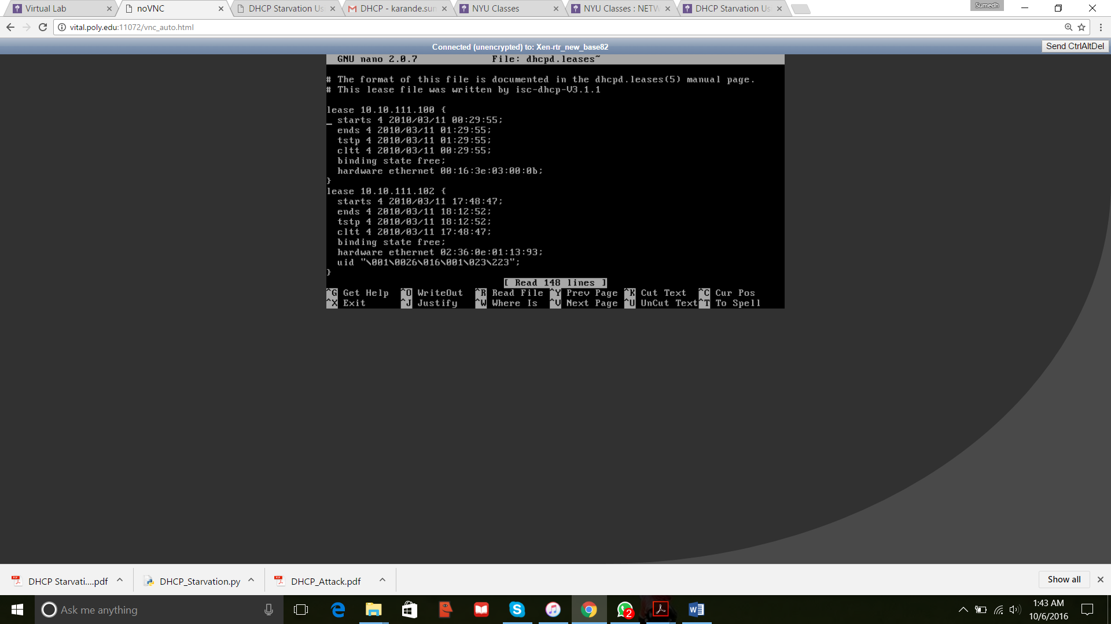

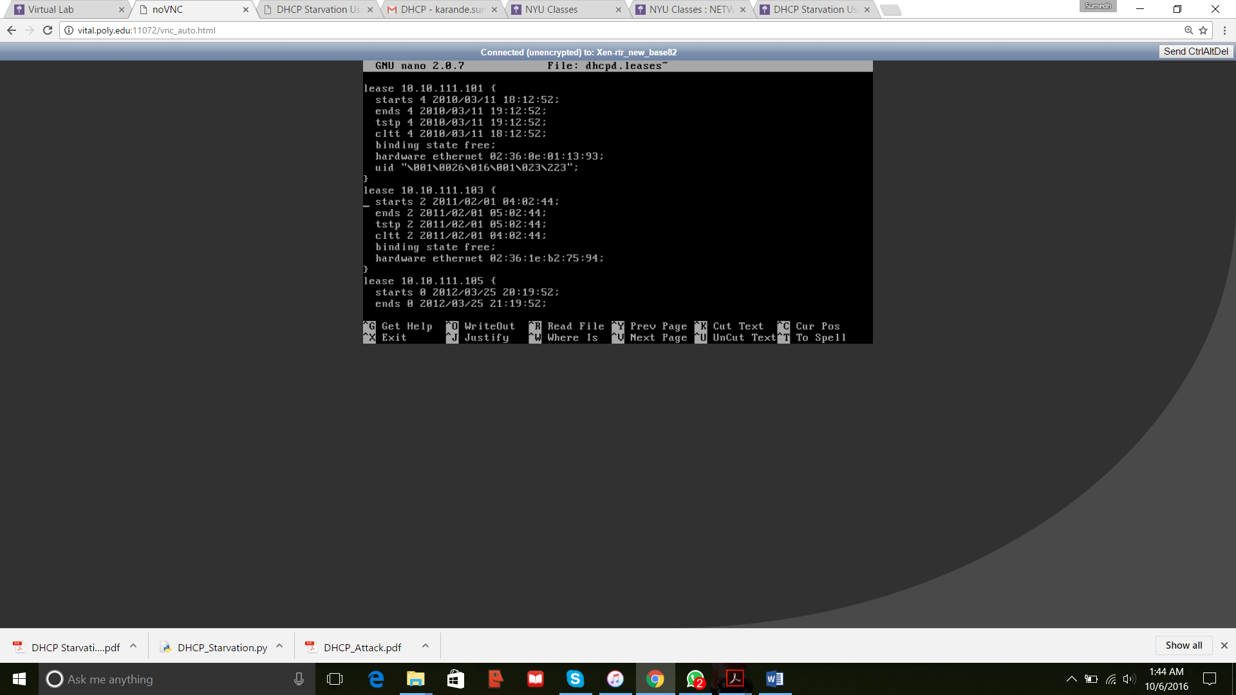

Leases after attack

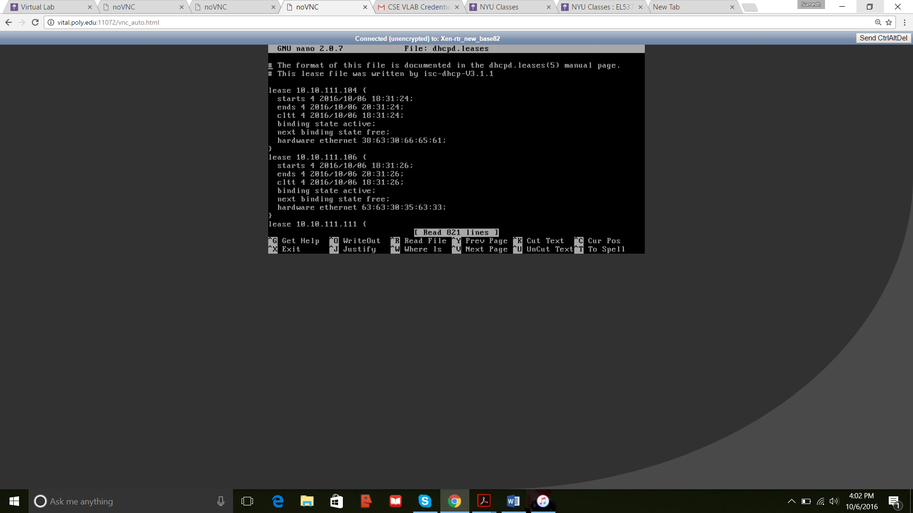

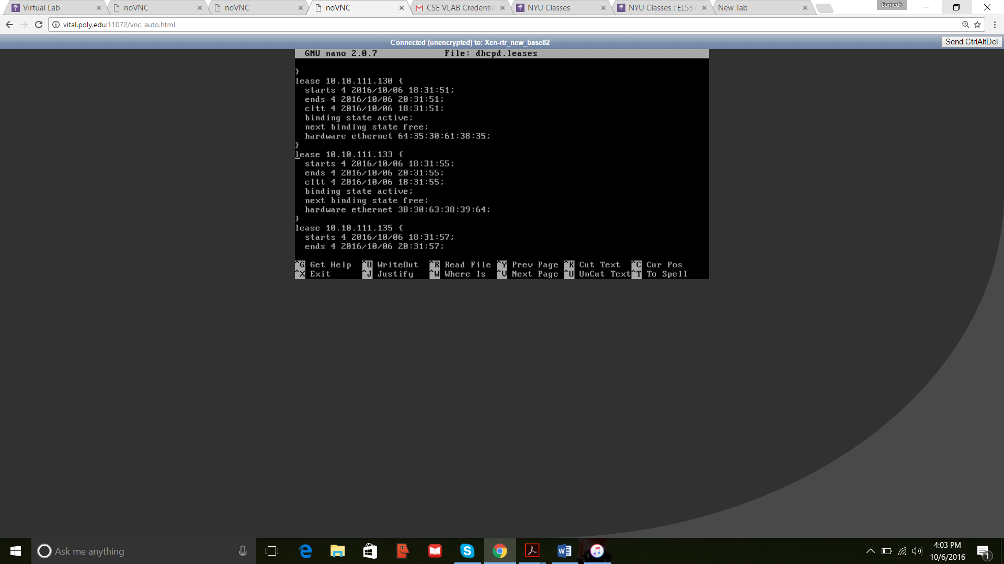

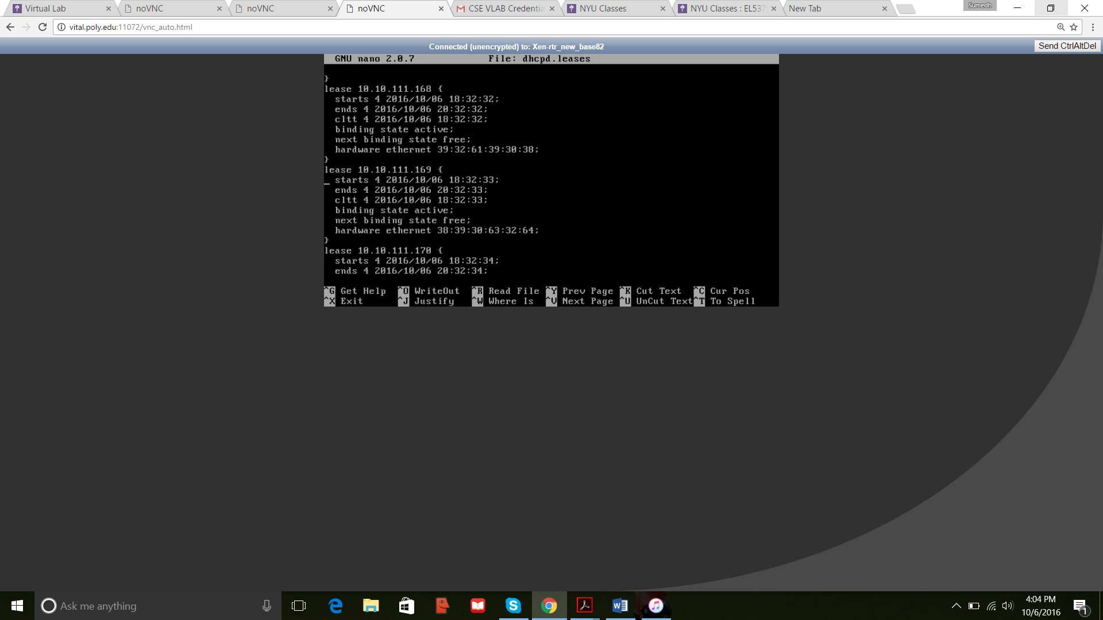

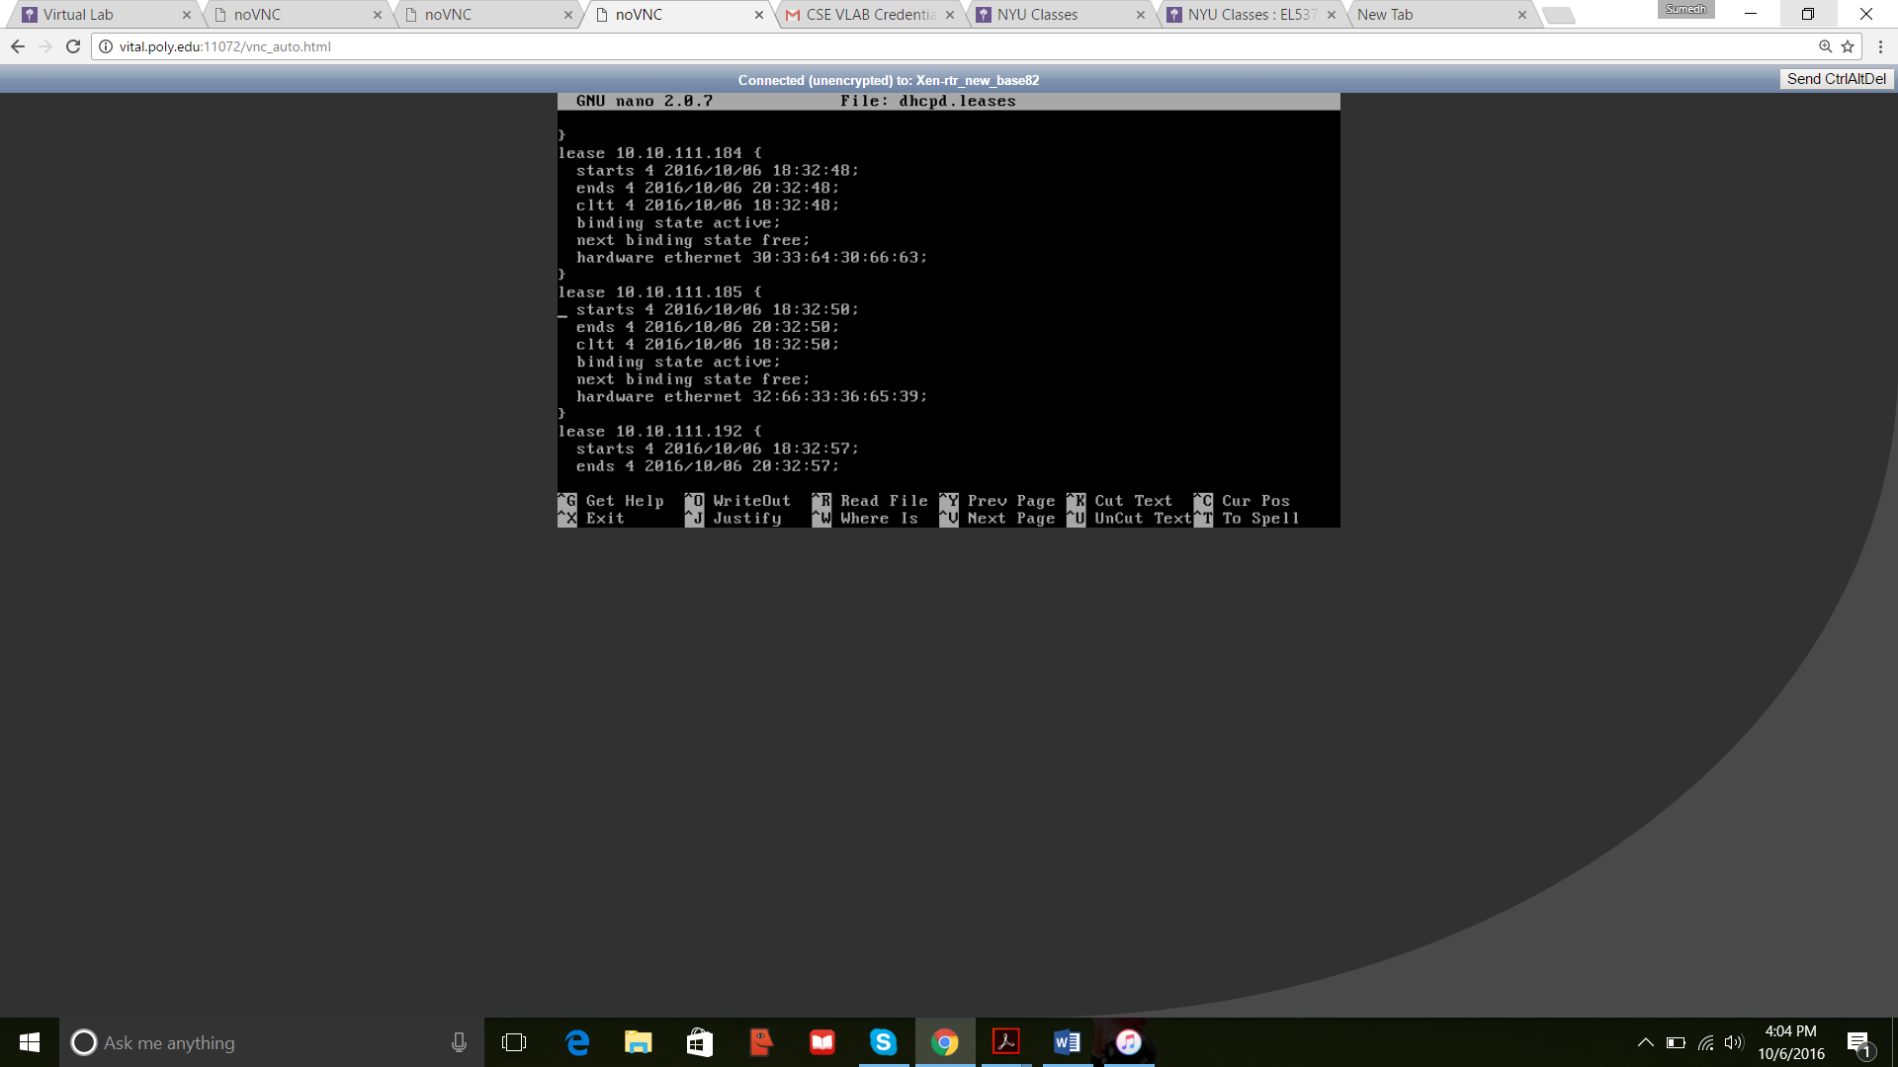

Bt5 Output

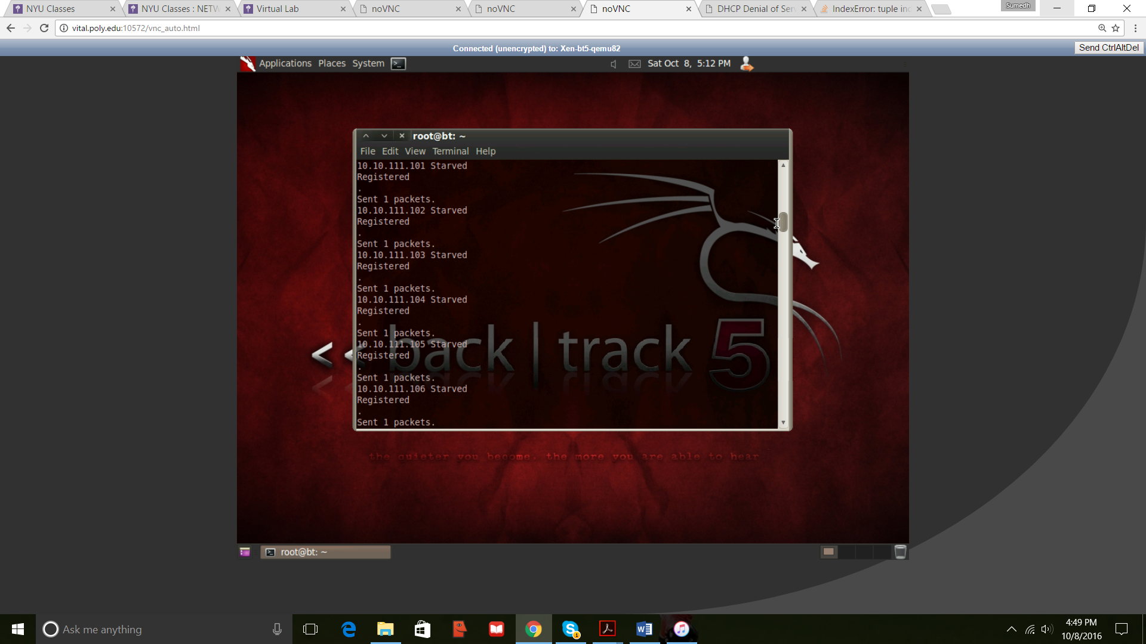

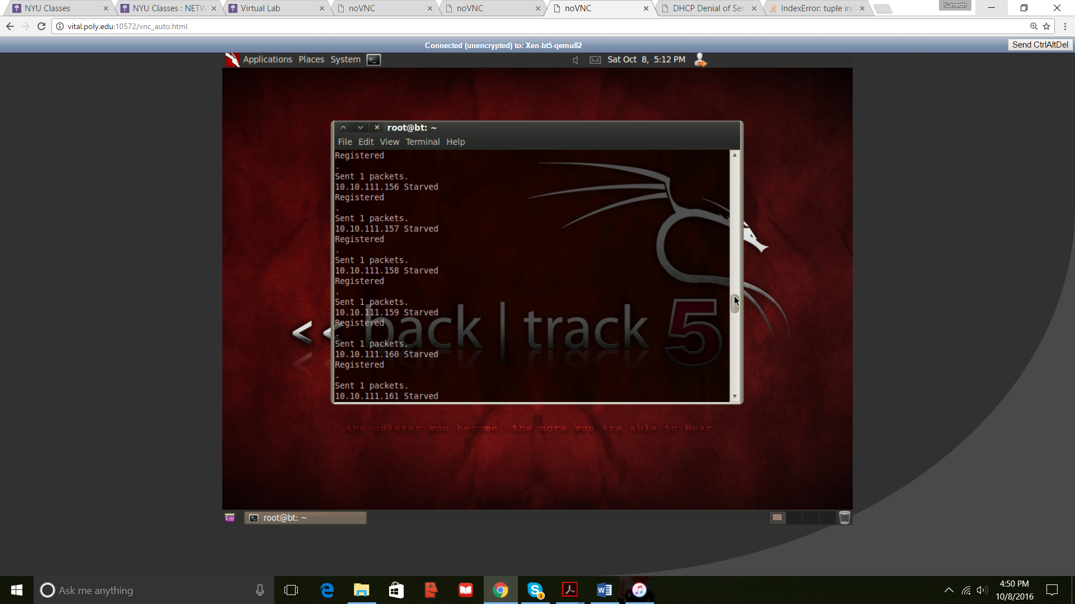

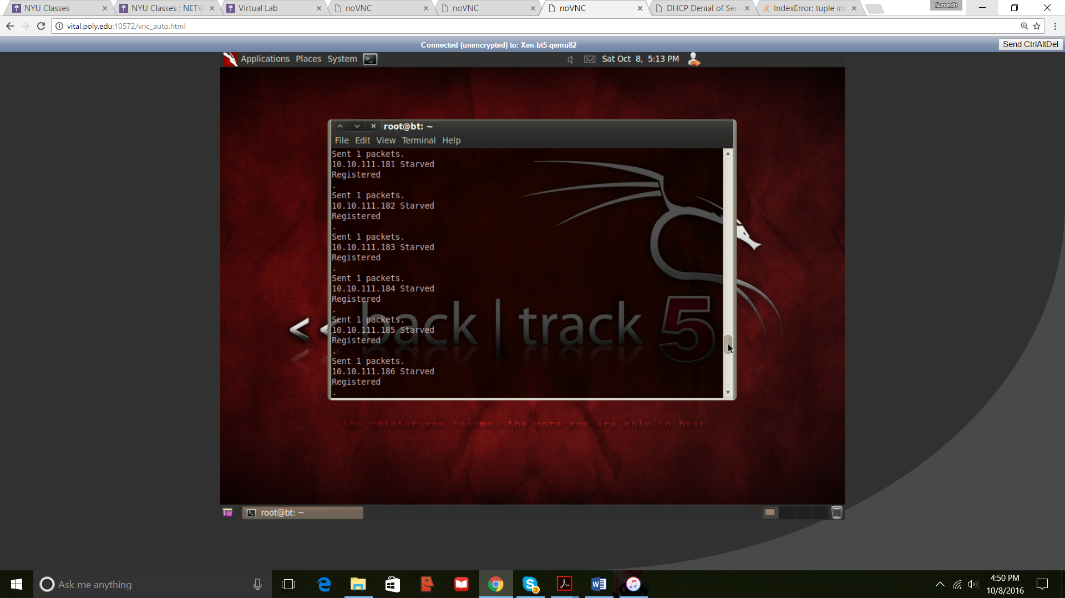

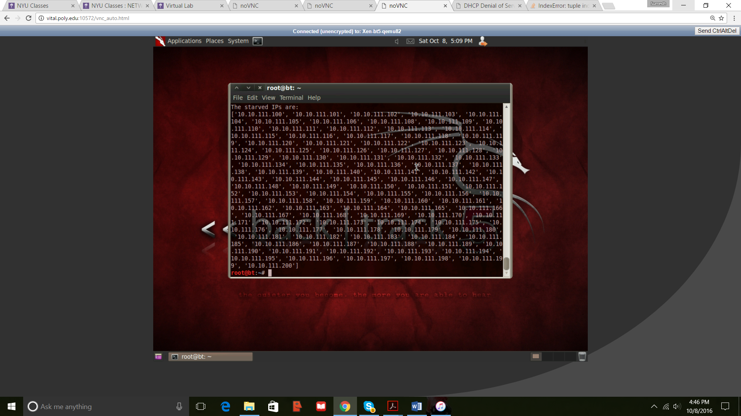

Wireshark Dump

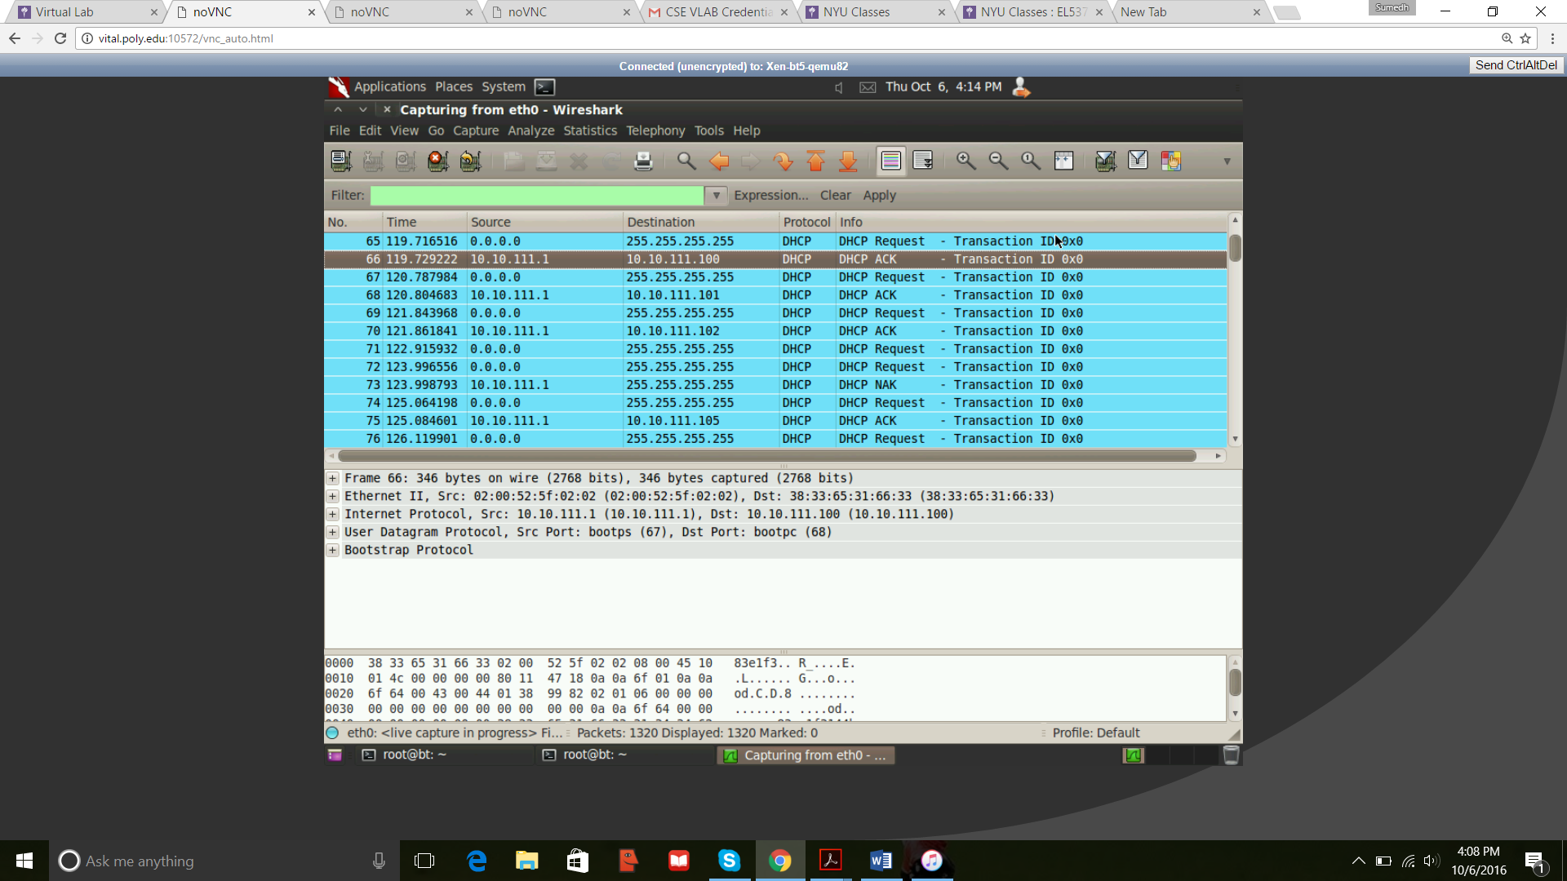

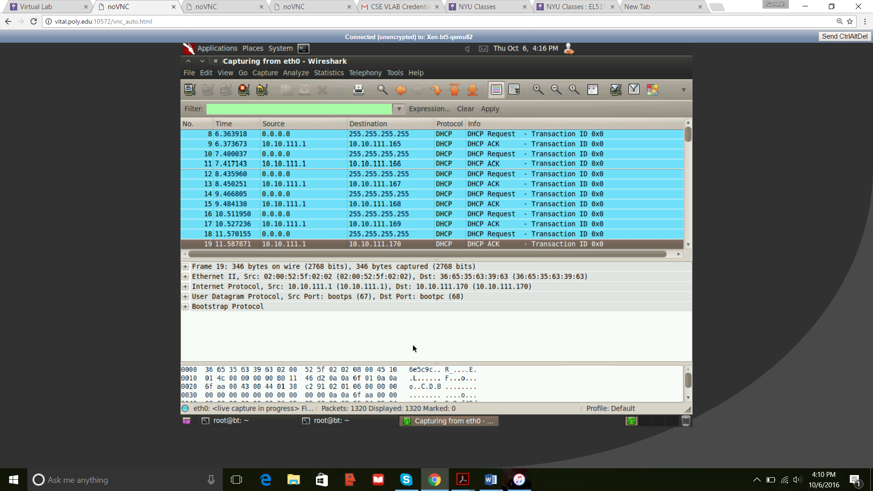

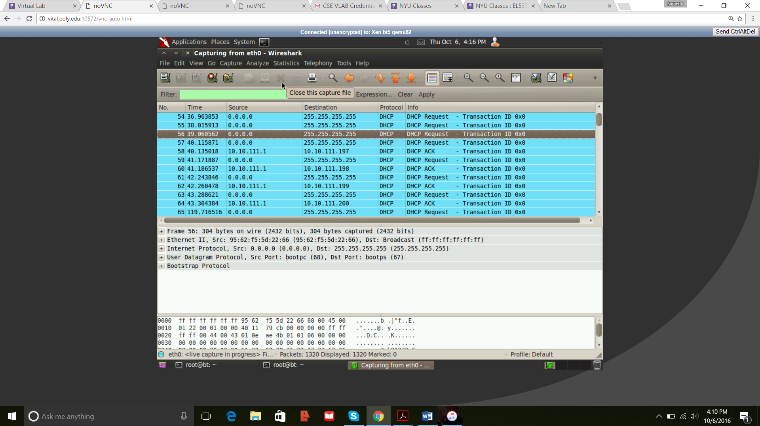

NAK Message

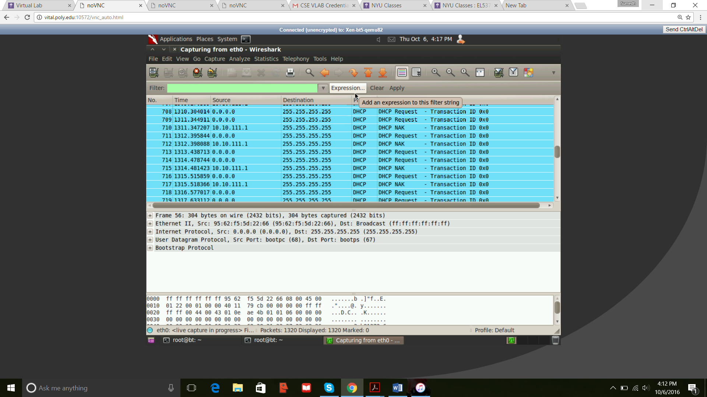

Output for Cmd of XP

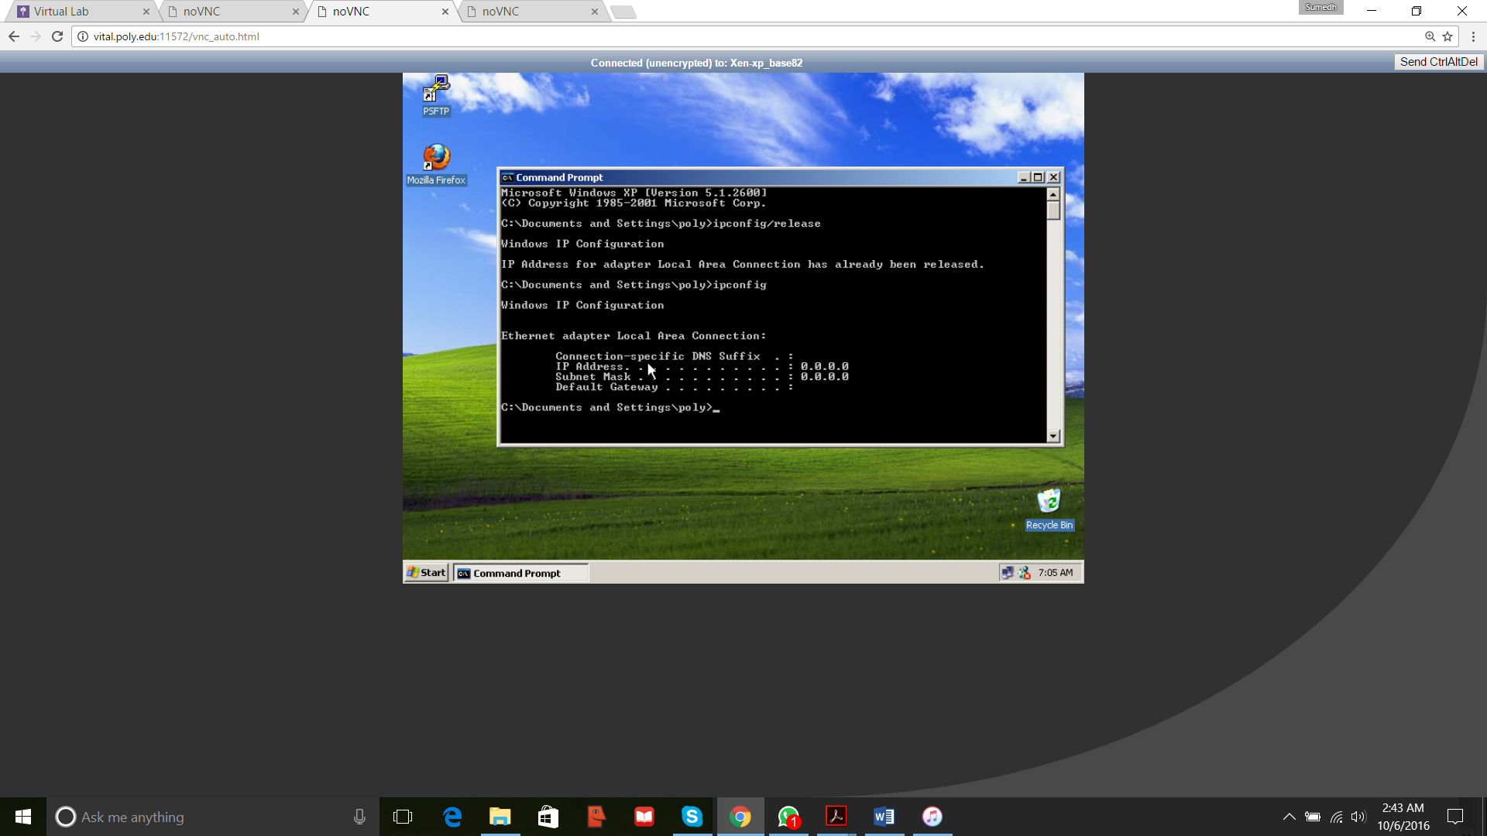

Request Timed-out.

